Day 1 (szeptember 08.)
Budapest-Szeged-Belgrade. Overnight stay in Belgrad, hotel Constantine the Great (35 Euro/person), only breakfast.
Some general tips:
All herein is a rough assessment; our tour definitely needs some flexibility and decision sometime to be made on the way. But, nothing to worry, we would just see more or less things depending on our efficiency, weather conditions but also our wills to stay longer on some attractive sites.
Food: At most of the places, we reserved HB (Half Board) – Diner / Breakfast. For lunches you have options to stop at some restaurant on the way (for some we could announce preferable food to be ready on arrival, for some we cannot do this because is impossible to precise schedule), or we could always in the morning stop at some market and take or make some sandwiches, buy water, etc.). It is up to (y)ours decision.
Money: We have three countries to visit. Although the languages are almost the same (I could freely say: equal) each of the country has its own currency and is good to have some local money with you:
Serbia (dinars) RSD / 1 euro = 118 RSD
Montenegro (euro is the currency)
Bosnia & Herzegovina (convertible mark) BAM / 1 euro = 1,95 BAM
From programme below you may roughly assess how much money you need for lunches, refreshment & drinks, entrances and tips.
Clothes: We are mostly geologists in the group, we will have some walk, entrance in caves, and so, but no difficult tour is envisaged. So, sport / walking shoes is OK. We would have probably all weather conditions on our tour, from a real summer hotness to mountain coldness in Durmitor Mts in Montenegro. The temperature there may drop to less than 10C over the night. We would thus need jackets, jumpers, long pants. For those going for rafting or when we walking through Kotor of course more light clothes are needed.
Information: We have not charged professional guides. My self and prof. Dragan Milovanović will do our best to present you geology, hydrogeology, and some facts about history, culture, local habits, nature and so. The maps, books, some brochures will be with us. However, in this modern informatic time you are advised, as we all are doing, to search a little bit over the internet for the places we are going to visit. This would also facilitate our talks and might direct us to some topics which you would like to learn more about. I hope we would have some guiding of local geologists during visit of Montenegro (I am managing but it still not confirmed).

Day 2 (szeptember 09.)
Belgrade - Faculty of Mining & Geology (welcome meeting of the Serbian Geological Society and University of Belgrade). Zoran will arrive to hotel to guide the group. After the breakfast, and check out of rooms with luggages stored in the bus, we will have a short walk to the Faculty for some 300m. Reception will be at 9AM in the Lecture Room, I floor, it will take about 30 min, as we are in hurry for that day tour.
Proceed to Valjevo, Bajina Bašta, Tara Mt. (karst spring Perućac, Reservoir Bajina Bašta on the border with B&H), Zlatibor ophiolite belt. Overnight stay in Zlatibor, hotel President (41,50 Euro/person), incl. half board (=HB)
I stop. Karst spring Paklje and newly built water reservoir Vrutci for regional water supply.
II stop Perućac karst spring and waterfall, Here I suggest to have lunch in restaurant Vrelo: trout fish (fresh from the spring) with potato and chards (price: ~8 euro + small wine 125ml 2.5 euro).
III stop a view over reservoir and Drina River in the top of Tara Mt.
IV stop a view over a small Tertiary basin of Kremna
V stop (if we are efficient and cave would be still open – means 18h): Zlatibor – Stopića cave (entrance 2.5 euro / 250 RSD; https://www.zlatibor.org/stopica-pecina/)
V stop alternatively: If we consider that would not be sufficient time to reach Stopića Cave, we may turn the bus for short visit of ethnic style village of Mokra Gora arranged by famous Serbian movie director Kusturica.
Overnight stay at Zlatibor / hotel President.
Bajina Bašta is situated on the right bank of the river Drina. Hydrographic picture of the area comprise course of the river Drina with its tributaries. Reservoir _{Peruć}ac was built on the river Drina, the biggest one in the whole course, covers 12 km² of area, 50 km in length, 70 m deep, at 290 m asl.
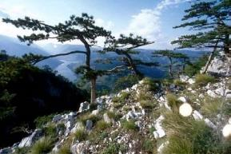
The Perućac spring and big waterfall, downstream of dam has average yearly discharge is Qav’~1.2 m³/s. The recorded minimum discharge is 0.4 m³/s, and the maximum is 9.0 m³/s. The catchment area is about 65 km².
The Tara National Park with its 19200 hectares covers most of Mountain Tara which lies on far west of Serbia.
The Mt. Tara area is covered by forests that are among the richest and most valuable of Europe in view of their diversity and extent of preservation. Among over 1000 herbal species, a special place is reserved for the "Queen of all Endemic Species in Europe" - the Pančić spruce. Deep canyons and preserved vegetation present the ideal habitat for many animal species. The Slopes of Mt. Tara are a temporary or permanent home for more than 100 species of birds, such as the golden eagle, the griffon vulture, the peregrine falcon, the big owl, the great grouse. In this area 24 species of mammals also live, and out of this number 17 are protected as natural rarity. Especially attractive are the brown bear, chamois, roe deer, wildcat, otter and others.
In the Tara canyons there are many traces of pre-history, ancient, Roman and Byzantine culture. The reconstructed Rača Monastery, the tombstone necropolis in Perućac and Rastište, are precious examples of Serbian medieval heritage, and it should also be stressed that Mt. Tara is a well known mountain tourist center.

Day 3 (szeptember 10.)
Zlatibor – Prijepolje (border with Montenegro) – Pljevlja – Durmitor Mt. Overnight stay in Žabljak, hotel Zlatni bor (41,50 Euro/person), HB
I stop (possible) Zlatibor: Stopića cave, if not visited on previous day.
II stop (optional, still to be confirmed based on our timing) Zlatibor: Gostilje waterfall
III stop Monastery Mileševa near Prijepolje (with famous White Angel frescoes).
The Mileševa monastery was founded between 1234 and 1236 by Serbian King Vladislav. White Angel, painted in 1230. Archangel (believed to be Gabriel) at the entrance of Christ's empty tomb, announcing His resurrection to the myrrh-bearing women.
IV stop Leaving Serbia / Entering to Montenegro, and then stop over the open coal mine of Pljevlja.
(possibly: crossing the town of Pljevlja and Husein-Pasha mosque (built in 1569).
V stop Djurdjevića Tara, famous bridge over the Tara River canyon. Here we split the group: 8 + one of us (Zoran ?) will go for rafting (2-3 hours, to be confirmed), the rest of group will continue to Žabljak / Durmitor Mt. where the visit of national Park HQ (open till 4PM) and glacial Black lake (Crno jezero) is envisaged.
The late lunch for the rafting group would be included in this river tour, while the rest of group may take some fast food from the market or from small food shop before visiting the lake.
The bus must come back to pick up rafting people, it is about 10km far.

Zlatibor Mt. is the fast growing mountain resort in Serbia and become one of the main touristic sites. Some of the remarkable geological sections with highly folded Late Paleozoic, Triassic and Jurassic formations will be visited.
Pljevlja city in Montenegro is the most beautiful mixture of Islamic and Christian spirit in every sense. The symbol of the city and everlasting tolerance are two cultural historic and architectonic monuments Monastery of Holy Trinity and Husein-Pasha mosque (built in 1569). Monastery of Holy Trinity dates back to 1537. Pljevlja coal basin is the largest in Montenegro and is situated in Neogene basin surrounded by thick Triassic limestones. Dewatering of mine is gravitational by big multiple-stage pumps, they let out water into the settling pond at the elevation 754 asl, and then into the Ćehotina River. To enable coal extraction original riverbed has been abandoned and new constructed.
On the way to Durmitor Mt. we shall cross Tara River, one of the UNESCO protected reserve. Tara canyon is more than 80 kilometers long and its deepest point is 1300 m below river bank, making to be the deepest canyon in entire Europe. Both banks are mainly built from Triassic limestones, while river water is turquoise clean.
Optionally: We may extend our stay for one more day to make rafting on the jewel of Europe, violent, clear and wild river Tara. There are several paths organized by experienced teams: long (all day), median (half day) and short (a few hours). The cost of short, including lunch and way back by vans should be ca. 40-45 euro. You may visit some web sites such as https://www.raftingmontenegro.com.
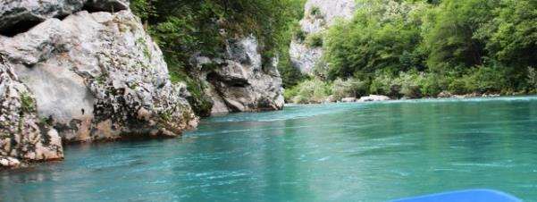

Day 4 (szeptember 11.)
Durmitor Mt. “Geological paradise” – Nikšić - Podgorica –Overnight stay in Podgorica, hotel Evropa (41,50 Euro/person), HB
This is most attractive part of the trip. The plan is to enter the mountainous area, but there are still the two options: one is to proceed across the mountain area over Trsa, and Piva Reservoir - Plužine towards Nikšić, and second is to take a shorter way, return from the mountain to the main road, and then proceed to Nikšić over Šavnik.
In Nikšić, the town which is settled in heart of the largest karstic polje of Montenegro (60 km²) plan is to visit HE system Perućica, consists of three reservoirs and several structures aiming to prevent water losses in highly permeable karst.

Durmitor is second highest mountain of Dinarides behind Prokletije mountain. The inhabitants of the region on the plateau between the rivers Tara and Piva, use the name Durmitor for the mountain which rises from this plateau, the highest peak being Bobotov Kuk (Ćirova Pećina) 2523 m high. In geographical writings, this highland area is referred to as "Durmitor in the limited sense". The word originates from a Celts expression: Dur-mi-tor (Water from the mountain, The mountain of many waters).
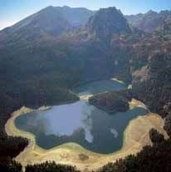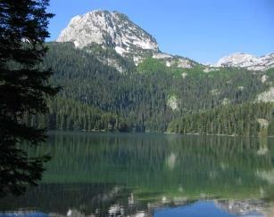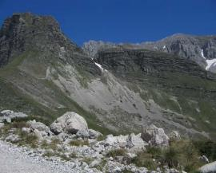

The great massive of Durmitor and the surrounding area
consists of Triassic and Jurassic reef limestone. Their
thickness is estimated at over 2000 m. Along with them
there are Cretaceous limestones. All the peaks east of this
line are formed from massive upper Jurassic limestone and
from limestone of the Upper and Middle Triassic. These are
sharp, rocky peaks with narrow valleys cut into the
limestone. The peaks west of this line (Cretaceous
limestone) are almost all rounded cupolas, with gentler and
broader valleys.
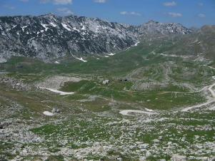
The coming of the ice age or the Pleistocene considerably changed the condition which formed the area of Durmitor and its immediate surroundings. The contemporary appearance of the peaks and valleys show vivid traces of the action of those powerful glacial deposits and streams. The peaks are very sharp and notched; the depressions were turned into cirques, and valleys partly into cirques and partly troughs.
After the plateau glaciers had melted, the Jezera plateau changed its appearance: numerous sinkholes, pits, depression covered by thick water-proof moraine drifts, numerous new escarpments and gentle slopes, this time formed from drifts. In this basins water accumulated, lakes (Vražje and Riblje jezero and many pools) and rivers however short, were created along with a rich covering of vegetation. The valley glaciers moved down on the southern side from many cirques.
Visit of glacial lake Crno jezero with two smaller basins are envisaged. Veliko (Great) and Malo (Small) length of the lake (both basins) is 1155 m and maximum width is 810 m. Maximum depth at the highest water level is 49m in Malo Jezero and 24,5m in Veliko Jezero.
Winters with a lot of snow and cool summers are characteristic of mountain climate of Durmitor. Average monthly temperatures at Žabljak is 4,9 ⁰C. Annual sum of precipitation on the plateau is 1500mm. (mean) and on the mountain 1750 mm.
Nikšić polje
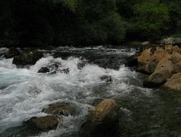
Spring „Glava Zete” main natural drainage point and HPP “Perućica” which is utilizing water from polje

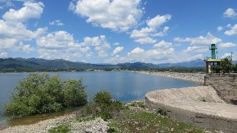
Reservoir Slano

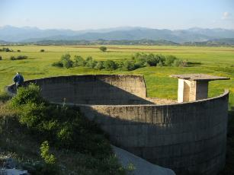 Cylindric dam Opačica
In the vicinity of Niksic from direction of Podgorica high in the cliffs is located greatest spiritual center of Montenegro Monastery of Ostrog.
Arrival to Podgorica, overnight stay, hotel Evropa (near Railway station)

Day 5 (szeptember 12.)
Bolje sestre water intake - Skadar Lake (boat tour) – proceed to Adriatic Coast – Kotor
.
Overnight stay in hotel Lavanda, 41,50 Euro/person, HB
Stop 1: Visit of intake structure at the lake shoreline. If bus will be too large to access the place, we shall have a short walk (1km). Visit of facilities, a short history of water problem. A small refreshment would be offered by our host director Mr Jevrić.
Stop 2: Virpazar, a small fishermen village. Boat tour (I hope would also be covered by our hosts).
Stop 3: Crossing 4,5 long tunnel Sozina to access the Adriatic side, a stop for photo over St Stephan luxury hotel-island.
Stop 4: Kotor UNESCO heritage city. Evening walk through the city and visiting springs next to city walls (optional).
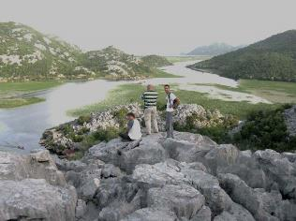
Skadar Lake is the largest lake on the Balkan Peninsula. The name is derivates from city of Shkodër on Albanian side of the lake. It is situated in the south-eastern part of the Republic of Montenegro, in Skadar – Zeta depression, and in the karstic terrain of the southeast Dinaric Alps in Albania. The mountains Lovćen, Sutorman, Rumija and Tarabosh lie on the southern side of the lake, while Skadar lowland lies on the eastern shore. Its northern coast is flat, gradually descending toward the lake, and it is covered with lush vegetation. The southern coast is steep and rugged. Skadar Lake is relatively shallow and the deepest part of the lake bed sinks below sea level, meaning the lake lies in a crypto-depression. Altitude is 5 m above sea level, the depth is minimum 5-9 m; maximum more than 60 m (Raduš spring eye). The Mora_{č}a River, with its two tributaries, Zeta and Cijevna/Cemi, contributes 62% of the lake’s water. About 30% of it comes from many sublacustrian springs called “eyes.”
Around 60% of the lake is in Montenegro, while 40% is in Albania. Average surface is 475 km². During Summer season it reduces on 370 km², while during Winter season reaches 540 km². Skutari Lake has a peculiar water regime, with water level fluctuations of up to five meters. Skadar Lake has status of the National Park since 1983. Ramsar site became on December 25,1995. It represents a real winter safe heaven for the most of European birds.
Bolje sestre is one of the submerged spring “eye” tapped today for water supply of entire Montenegrin Coast.
After boat tour around the lake the trip will continue via Sozina tunnel and cities along the coast of Montenegro (Petrovac, Budva) until Kotor the world heritage city and old port in Boka Kotorska bay.
South of Kotor Fortress, in its immediate vicinity, there is the main spring, Gurdića spring. Its precipice is under the sea level for over 20 m. Through this spring, vast and up to now inestimable underground water guantities, coming from the Lovćen massif, discharge. This is a brackish spring containing Cl ions in the concentration which prevents its use as potable water. It was noted that it can happen sea water sinks into the Gurdića spring precipice exceptionally dry year. However, it happens once in 10 years in average, although it does not occur as a rule.
Northward from Kotor, also in the immediate vicinity, there is a karst spring called Škurda. This is a brackish spring in fact.

Day 6 (szeptember 13.)
Kotor – Risan - Trebinje (Bosnia & Herzegovina). Overnight stay in Trebinje, hotel Viv (20 Euro/person by cash, 26 Euro/person, HB
Kotor, after breakfast: Free time for visit the cathedral, Marine Museum and short city walk.
Stop 1: Ljuta spring
Stop 2: Risan / Sopot cave - temporary spring
Stop 3: “Stone sea” – view point over Boka Kotorska in highly developed karst with many deep potholes
Stop 4: Grahovo a small karst polje.
Stop 5: Border Montenegro / Bosnia & Herzegovina
Arrival to Trebinje, hotel VIV. A short walking tour, old town, Arslanagića bridge, Trebišnjica River, (optional: visit of some of local winery, wine testing and a small food: cheese / ham, is c. 5-8 euro, have to be reserved in advance).
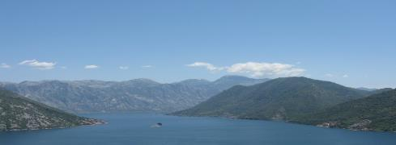
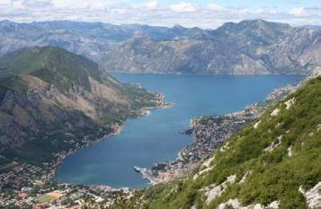
The Old Town of Kotor is one of the best kept mediaeval towns in this part of the Mediterranean. It has managed to keep its structure typical of towns from the XII to XIV century. The asymmetric structure of narrow streets with medieval monuments contributed, among other beautiful buildings, to Kotor being entered into the UNESCO Registry of World Cultural Heritage and Natural Beauties. The fortification of Kotor is of world value. It includes a 4.5-km long wall, which is 20 m high and 15 m wide and protects the town from waves. The construction of the wall started in Illyrian times and continued until the XVIII century. A representative example of Romanesque architecture on the Adriatic coast is the magnificent St Tryphon’s Cathedral which was built in 1166 on the remains of a previous temple from the IX century. Frescoes in the cathedral date back from the XIV century and there is a rich treasury with local and Venetian jewellery from the XIV-XX century. In addition to the cathedral, a great heritage of sacral architecture from the XII-XX century has been kept at several cathedrals and churches.

Most of the karstic brackish groundwater in the area of Kotor is drained through the karst springs of Gurdić, Škurda and Tabačina. The catchment area of these springs is quite broad and includes the karst terrain of Mt. Lovćen and the village of Njeguši.

The city of Kotor and the Boka Kotorska Bay. Panoramic view from Mt. Lovćen (www.unmissable.com)
The Sopot Spring is located on the right side of the main Risan - Herceg Novi road, 2 km away from Risan. The upper outlet is the cave but it is active only during periods of intensive rain that cause big floods underground. Rainfall from the Orjen Mountain and Stone Sea zone above Risan quickly infiltrates into the highly karstified massive Cretaceous limestones. The discharge is predisposed by the contact with Eocene flysch sediments. This periodical discharge is impressive and the spring cave functions with one of the world’s largest discharge, over 150 m³/s (some estimates even indicate 200 m³/s, but measurements are extremely difficult due to local topography). Water then flows for some 50 m and over a cascade of around 20 m high falling noisily to the sea. During the summer season only the two submarine springs (locally ‘vrulja’) are active and they drain the Sopot aquifer system. The diving exploration located main discharge points in a small bay near the Sopot, at depths of 28 m and 36 m. Concentric circles in the bay indicate the discharge zone. Actually, they represent the erosive basis of the entire catchment area.
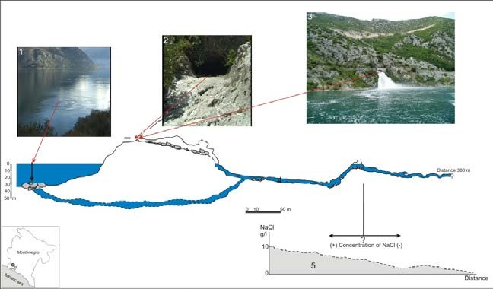
Cross section of the Sopot Spring (after Milanović S., published in Stevanović Z. et al. 2010)
The Stone Sea (Kameno more) area is based at the hinterland of Boka Kotorska (Montenegro), north from Risan Bay. The direct distance from the furthest southern point of Kameno More to the sea is about 600 m. The altitudes range from 500 m.a.s.l. to 1,200 m.a.s.l., but the largest part of the Kameno More area is between 600 m.a.s.l. and 800 m.a.s.l.
The karstified limestones are completely exposed and heavily fractured and folded. Typical holokarst phenomena such as karren, sinkhole, and pits are widely present.
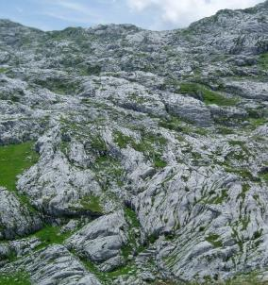

Detail of the Stone Sea area (photo S. Milanovic)

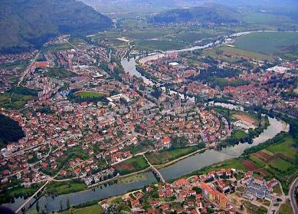
The area of Trebinje City is in the southernmost part of Bosnia & Herzegovina and the Republic of Srpska. Trebinje City covers an area of 904 km², and it is just 30 km far from famous Dubrovnik (Croatia) UNESCO heritage city.
Visit of Vjetrenica cave, Hydropower structures –
Grančaravo and Gorica dams, visit of Tvrdaš Monastery and some of the local wineries are envisaged.

Panoramic view of Trebinje (http://www.visitmycountry.net)
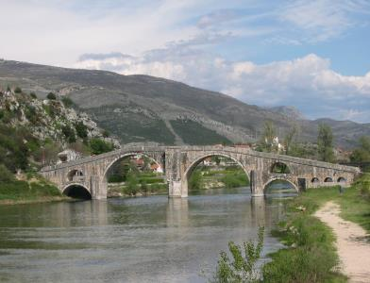

The Arslanagića (Perovića) Bridge built by Mehmedpasha Sokolović, the Great Vezir (Prime Minister) of the Ottoman Empire in 1574 to commemorate the death of his son killed in war against the Venice Republic. The bridge was removed from its previous location during the construction of the Trebišnjica HE system

(photo P. Milanović)

Day 7 (szeptember 14.)
Trebinje – via Popovo polje, Stolac to Mostar. Overnight stay in Mostar (Villa Milas), 35 Euro/person) és 27 Euro/fő (3 ágyas szobákban) with cash; HB
Stop 1: Trebišnjica channeled river, the former largest sinking stream in Europe.
Stop 2: Vjetrenica cave
Stop 3: Stolac – Radimlja medieval megalithic tombs site
Stop 4: Vrelo Bune – one of the European largest springs

Mostar – old city and famous bridge walking tour
Hotel Villa Milas
The Popovo Polje is a specific example of karst phenomena. A number of geomorphologists, geologists and engineers have analyzed this polje from different view points (Groller, Ballif, Katzer, Grund, Daneš, Penck, Absolon and others). Cvijić (1909-1926) was the first to organize systematic geomorphological, hydrogeological and speleological investigations presented in his work ‘The old outflows of Popovo Polje’ and ‘Hydrographic zones in karst’.
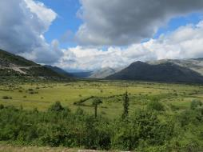
The thickness of the Cretaceous carbonate rock mass in the polje area is more than 3,000 m. The Popovo Polje is subdivided into a wide corrosion plateau, the Trebinjska Šuma (the Trebinje Forest), with a flat rocky surface and the Popovo Polje covered with alluvial deposits (Fig. 1). The thickness of the alluvial cover increases in the direction of the slope of the polje. In its upper part, the alluvium is only 1-2 m thick, and in its lower portion it reaches a thickness between 15 - 20 m. The surface of this part of the polje is 68.4 km2 and the width varies between 1 and 2 kilometres.

The Popovo Polje (photo Z. Stevanović)

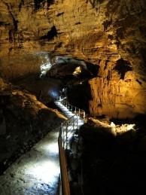
The Vjetrenica Cave (Windy cave) is located in the south-western rim of the Popovo Polje. It is the most explored speleological object in the karst of eastern Herzegovina. Investigation of the Vjetrenica Cave (Fig. 6) started at 1858 and the length of surveyed channels has reached 7,503 m. Some 1,250 m has been adapted for tourist visits. The main channel is sub-horizontal and is passable until the Veliko jezero hall (Big Lake). In the 1960s another lateral channel with water flow was discovered by the speleologists. Its length is around 200 m.
More than 50 different underground species have been recorded in this cave. Seventeen of them have been declared as endemic species. The fossilized skeletons of leopards and bears have been discovered in Vjetrenica’s channels as well. A well-known cave-dwelling aquatic endemic species Proteus anguinus (the ‘human fish’) was found in 37 localities of the Popovo and Trebinjsko poljes including the urban area of Trebinje
An interesting example is the Gaovica fish (Paraphoxinus ghetaldi) which spends dry (summer) months in numerous syphonic lakes and estavelle pools.

The necropolis on Radimlja is the best known site in Herzegovina containing stećci, the medieval tomb stones. It is located 3 km west of Stolac, along the Stolac – Čapljina road, in Vidovo polje, near Paprati village.
The necropolis is among the most valuable monuments of the medieval period in Bosnia and Herzegovina. The characteristics underlining its value are: large number of samples, variety and representativeness of all basic forms, relatively high artistic quality of work, variety of plastic ornaments, reliefs and titles mentioning historical personalities, as well as its availability and location.
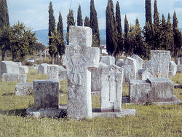
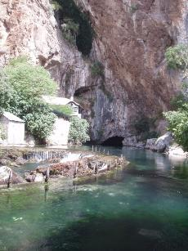
The Buna Spring is one of the most fascinating karst springs for karstologists and tourists worldwide. The spring outlet is situated at the tectonic contact between Cretaceous limestone and Eocene flysch, at an elevation of 36 m. Water discharges from the cave underneath the high cliff. At the cliff, side openings are visible that were created at some earlier stage of the Karst aquifer evolution process. Buna is a siphoned spring. The total length of the deep siphons explored by divers is 520 m, while the vertical distance between the deepest explored and the discharge point is 72 m (C. Touloumdjian, 2005).
The total estimated catchment area of the Buna Spring is about 900 km² including the Nevesinjsko Polje, the catchment of the Zalomka River and the broad area of the Velež Mountain at an elevation above 900 m. All the water percolating along the Zalomka River and the Nevesinjsko Polje discharges at the Buna Spring, except water which sinks into the last ponor - Biograd. Spring discharge varies between 2.95 m³/s minimum, and 380 m³/s maximum

The Buna Spring with the Blagaj Tekke (photo P. Milanović)

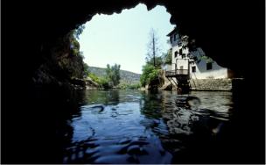

View from inside the Buna Spring (photograph courtesy of Claude Touloumdjian)
The old town, which dates back to the Ottoman period, has always been the main attraction in Mostar. The old market, Kujundžiluk, was named after the traditional goldsmiths that made and sold their hand-made products on the street, and this is also the place where you can find authentic pictures and copper or bronze engraving plates of the Old Bridge, pomegranates (the natural symbol of Herzegovina) or the well-known stećci (medieval tombstones).
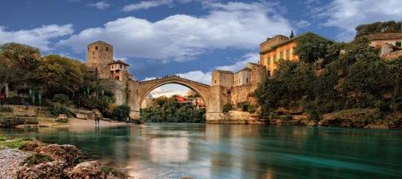 https://www.visitmycountry.net/bosnia_herzegovina/en/
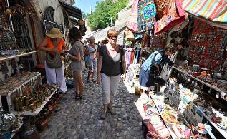
https://www.visitmycountry.net/bosnia_herzegovina/en/

Day 8 (szeptember 15.)
Travel back to Belgrade. Overnight stay in Belgrade, hotel Constantine the Great (35 Euro/fő).
Only breakfast.

Day 9 (szeptember 16.)
Travel back to Budapest

